Brookside Sweets

Flourless Chocolate Cake 12

Raspberry Mascarpone Cheesecake 12

Panna Cotta 10

Mixed Berries 12

Selection of Ice Cream & Sorbet 12

Cheese Plate 14

Chef’s Dessert Sampler 14

Dessert Beverages

CHOCOLATE TOASTED ALMOND MARTINI 12

Amaretto di Saronno, Godiva Chocolate Liqueur, Irish Cream Liqueur

CARRIAGE HOUSE HOT MOCHA 12
Colombian Coffee, Kahlua, Crème de Cacao, Giffard Vanilla Liqueur

CHOCOLATE COVERED RASPBERRY MARTINI 12

Stoli Razz Vodka, Godive Chocolate Liqueur, Irish Cream Liqueur

RED VELVET CAKE MARTINI 12

Frangelico Hazelnut Liqueur, Ketel One Vodka, Crème de Cacao, Grenadine

Fresh Brewed Colombian Coffee, Hot or Iced 4

Steven Smith Teas 4

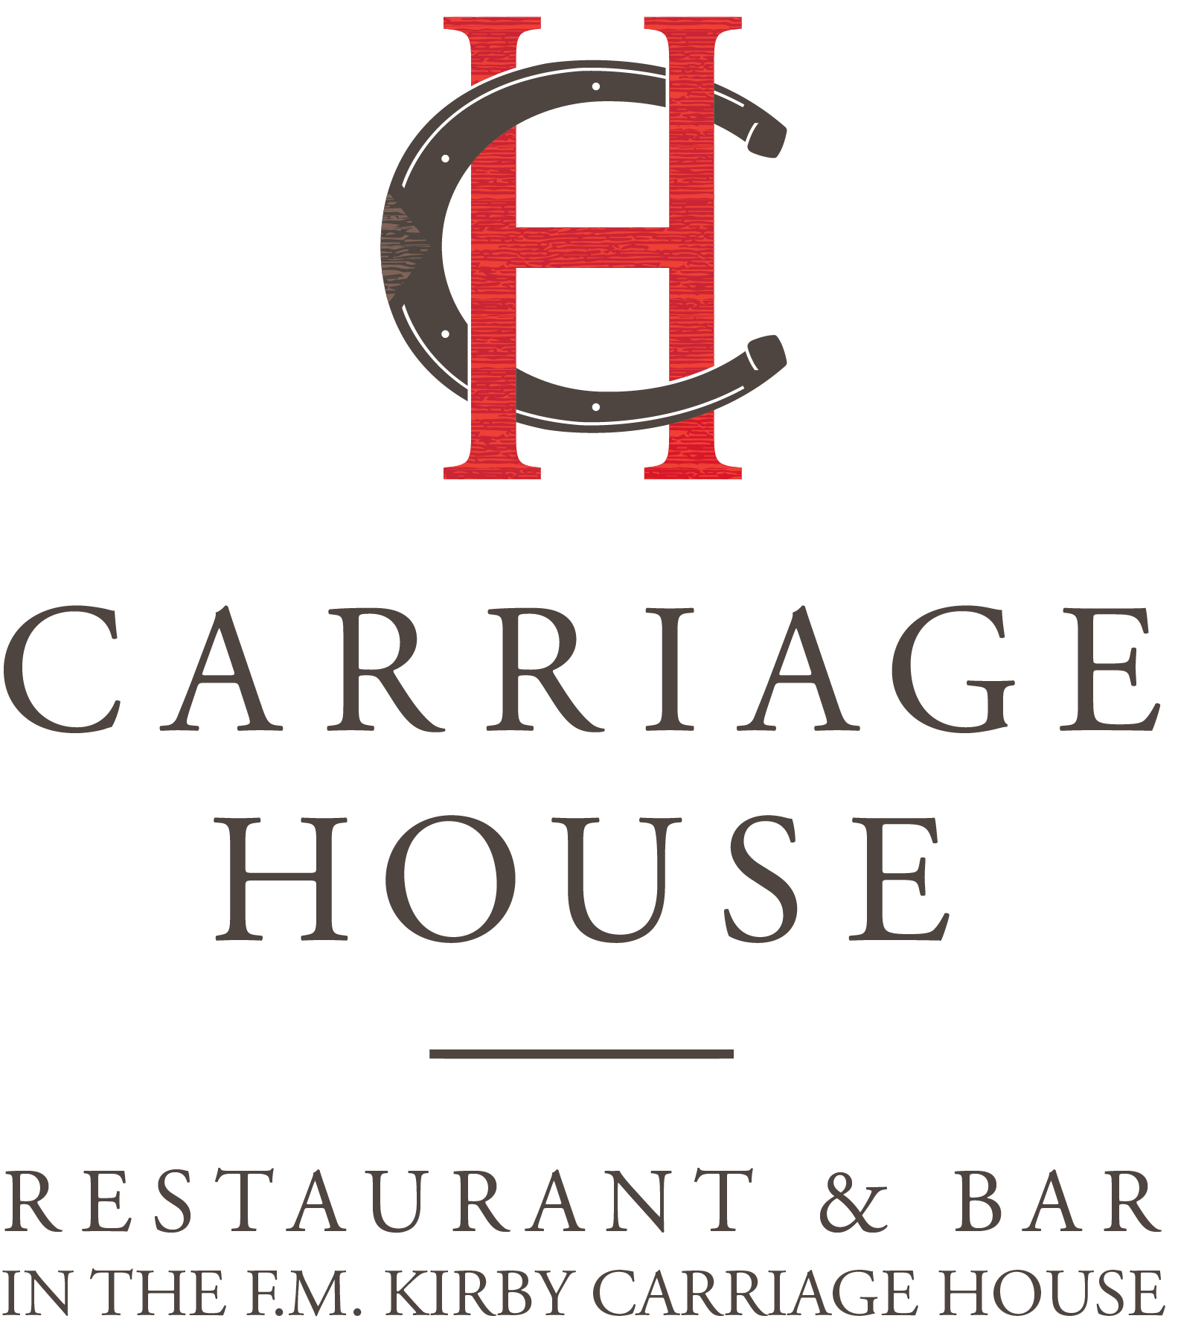
Small Plates

Chilled Asparagus Salad 12

Baby Red & Yellow Tomatoes, Shaved Parmesan, Lemon Dressing

Roast Duck Quesadilla 16

Pepper Jack Cheese, Pico de Gallo, Guacamole, Sour Cream, Tomatillo Salsa Verde

Smoked Salmon 16

Capers, Red Onion, Chopped Egg, Crème Fraiche, Croutons

Cheese Plate 14

Selection of 3

Summer Crudité 15

Rainbow Carrots, French Breakfast Radish, Confetti Baby Tomatoes, Niçoise Olives,

Curried Yogurt Dip, Grilled Pita

Angus Beef Sliders 16

Gruyere Cheese, Pickled Red Onions, Spicy Sriracha Aioli

Blistered Shishito Peppers 12

Dusted with Spicy Togarashi, Wasabi Aioli & Ponzu Dips

Side of Fries 8

Desserts
Flourless Chocolate Cake 12

Raspberry Mascarpone Cheesecake 12

Panna Cotta 10

Mixed Berries 12

Selection of Ice Cream & Sorbet 12

Chef’s Dessert Sampler 14

Cheese Plate 14
`
BROOKSIDE CABARET UNDER THE STARS
Carrot Ginger Soup
Miso Glazed Shitake Mushrooms, Lime Crème Fraiche, Cilantro Oil

Chilled Asparagus Salad
Baby Red & Yellow Tomatoes, Shaved Parmesan, Lemon Vinaigrette

Watercress & Endive Salad
Point Reyes Blue Cheese, Toasted Walnuts, Red Wine Vinaigrette

Red & Yellow Beef Tomato Salad
Red Onions, Niçoise Olives, Capers, Feta Cheese, Fresh Oregano
3.00 Supplemental

Smoked Salmon Plate
Capers, Red Onion, Chopped Egg, Crème Fraiche, Croutons
7.00 Supplemental
********
Brookside Burger
Gruyere Cheese, Red Pickled Onions Sriracha Aioli, Fries

Mezza Rigatoni
Roasted Eggplant, Tomato Parmesan Crema, Fresh Basil

Oven Roasted Chicken Breast
Pomegranate Glazed Carrots, Jicama Orange Salad, Grilled Red Onion Serrano Chili Vinaigrette

Atlantic Salmon
Tri-Color Pearl Couscous, Cucumber Yogurt Salad, Warm Roasted Tomato Vinaigrette
5.00 Supplemental

NY Strip Steak Frites

Horseradish Mustard Compound

10.0 Supplemental

30 per person for Two-Course Dinner
Sales Tax and Gratuity are not included

