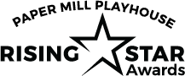

MEDIA RELEASE FORM

The Paper Mill Playhouse Rising Star Awards like to get your permission to use submitted video or photos, or portions of it, for Paper Mill's use.

If you agree to grant us permission for such use, please check both boxes below and complete with your signature:

I grant to Paper Mill Playhouse the right to record my child in connection with the above-identified event and authorize Paper Mill Playhouse to copyright, use and publish the same in print and/or electronically.

I agree that Paper Mill Playhouse may use such video and/or photography of my child with or without their name for any lawful purpose, including for fundraising and marketing purposes.

Student Name _____________________________________________________________________________

PARENT SIGNATURE _______________________________________________________________________

